Flash firmware to HeishaMonBoth board

1. **Upgrade file by Webserwer**

Go to Setting > Firmware

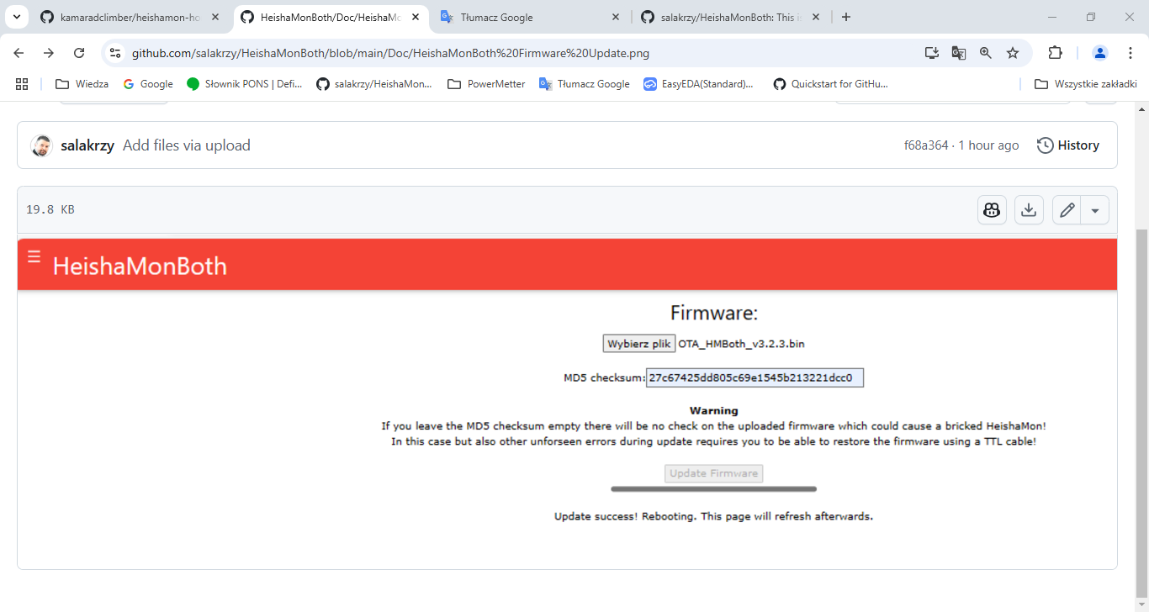

1. **Using USB to TTL Serial converter**

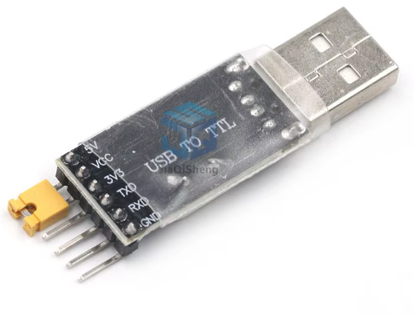

Copy the directory <https://github.com/salakrzy/HeishaMonBoth/tree/main/FlashFirmware> to your computer

Close “boot” pins on the board and connect the “ UART0” pins with USB converter.

Remember Tx pin from board goes to Rx pin in converter and Rx from board goes to Tx.

Connect only the Tx,Rx,GND and +5V pins. Disconnect board from Heat pump!!!! Power will be provided by converter.

**Go to the local directory and run UART_flash.bat or OTA_flash.bat**

You could see something like this

esptool.py v2.3.1

Connecting........_____....._____....._____.....___

Chip is ESP32D0WDQ5 (revision (unknown 0xa))

Features: WiFi, BT, Dual Core, Embedded Flash, VRef calibration in efuse

Uploading stub...

Running stub...

Stub running...

Changing baud rate to 921600

Changed.

Configuring flash size...

Auto-detected Flash size: 4MB

Compressed 18928 bytes to 13069...

Wrote 18928 bytes (13069 compressed) at 0x00001000 in 0.2 seconds (effective 809.8 kbit/s)...

Hash of data verified.

Compressed 3072 bytes to 157...

Wrote 3072 bytes (157 compressed) at 0x00008000 in 0.0 seconds (effective 1536.0 kbit/s)...

Hash of data verified.

Compressed 1102304 bytes to 665904...

Wrote 1102304 bytes (665904 compressed) at 0x00010000 in 9.4 seconds (effective 937.4 kbit/s)...

Hash of data verified.

Compressed 57344 bytes to 722...

Wrote 57344 bytes (722 compressed) at 0x00391000 in 0.0 seconds (effective 28671.9 kbit/s)...

Hash of data verified.

Leaving...

Hard resetting via RTS pin...

d:\PlatformIO_GIT\Flash HeishamonBoth>pause

Press any key to continue . . .

**Disconnect boot jumper and restart power**

**You can clear all ESP32 flash memory using command eraseesp.bat**